JAVA PROJECT:

SLIDE 1: Car Rental Fleet Manager
Programming for Problem Solving (PSPJ) – Java
Presented by: Gundu Meghana
SLIDE 2: Abstract
The Car Rental Fleet Manager is a console-based Java application designed to manage a small fleet of rental cars. It demonstrates fundamental programming concepts through a practical problem-solving approach.
Core functionality: View cars, search vehicles, check availability, rent/return cars, calculate charges, sort by price
Technology: Pure Java with arrays, methods, and control structures

SLIDE 3: Problem Identification & Objectives
Problem Statement
Manual fleet management makes it difficult to track car availability, rental prices, customer selections, and rental duration efficiently. A structured programmatic solution is required.
Input → Process → Output Model
User commands feed into control-flow logic, which processes fleet arrays and delivers formatted console output — a direct demonstration of the IPO model from Module 1.
Project Objectives
- Maintain car information - ID, model, price per day, availability status
- Search & display cars - Filter by ID or name using overloaded methods
- Manage rent & return - Update availability and compute charges dynamically
- Sort fleet by price - Bubble sort across parallel arrays using nested loops
Advantages of the Project
- Real-world problem solving - Demonstrates practical application through a car rental management scenario
- Integrated learning - Combines key programming concepts from Modules 1–3 in one cohesive system
- Scalable design - Uses arrays and modular methods to support clean expansion and maintenance
- Easy to understand - Simple structure makes the project approachable for learning and modification
- Pure Java implementation - No external dependencies — built entirely with core Java features
- Core concepts covered - Covers control flow, data structures, sorting, and modular programming
SLIDE 4: Module-Wise Concept Mapping
MODULE 1: Java Fundamentals
- Computational thinking, algorithm design, flowchart
- Variables, primitive data types, arithmetic operators
- Scanner input, formatted console output
MODULE 2: Control Flow
- if-else, switch, nested conditionals
- for, while, do-while loops
- break, continue statements
MODULE 3: Modular Programming
- Methods with parameters and return values
- Method overloading, arrays, enhanced for loop
- Searching and sorting algorithms
SLIDE 5: System Design & Data Structures
Fleet Information Storage (Arrays):
- carId[] = {101, 102, 103, 104, 105}
- carName[] = {"Swift", "Baleno", "Creta", "City", "Nexon"}
- pricePerDay[] = {1500, 1700, 2500, 2200, 1800}
- available[] = {true, true, false, true, true}
- rentalDays[] = {0, 0, 0, 0, 0} (tracks rental duration)
Array indices correspond to the same car across all arrays.
SLIDE 6: Algorithm & Program Flow
Main Algorithm
- Initialize car fleet arrays
- Display main menu
- Read user choice via Scanner
- Use switch to execute selected operation
- Call appropriate method with parameters
- Display result using formatted output
- Loop back to menu (do-while)
- Exit when user selects option 8
Flowchart: START → Menu → Read Choice → Switch Decision → Execute Method → Display Result → Loop/Exit → END
SLIDE 7: Implementation: Key Methods
Method Signatures (Module 3)
- void displayCars() – Enhanced for loop, arrays
- int searchCar(int id) – Linear search, returns index
- void rentCar() – if-else, Scanner input, availability check
- void returnCar() – Updates availability, calculates charges
- int calculateRent(int days, int price) – Arithmetic operators, return value
- void sortCarsByPrice() – Bubble sort, nested loops
- void displaySummary() – Counting, averaging techniques
Method Overloading Example: searchCar(int id) and searchCar(String name)
SLIDE 8: Complete Java Implementation
import java.util.Scanner;
public class CarRentalFleetManager {

// MODULE 1: Arrays & Variables
static int[] carId = {101, 102, 103, 104, 105};
static String[] carName = {"Swift","Baleno","Creta","City","Nexon"};
static int[] pricePerDay = {1500, 1700, 2500, 2200, 1800};
static boolean[] available = {true, true, false, true, true};
static int fleetSize = 5;

public static void main(String[] args) {
Scanner sc = new Scanner(System.in);
int choice;
// MODULE 2: do-while loop
do {
displayMenu();
System.out.print("Enter your choice: ");
choice = sc.nextInt();
// MODULE 2: switch statement
switch(choice) {
case 1: displayCars(); break;
case 2: searchCarMenu(sc); break;
case 3: rentCar(sc); break;
case 4: returnCar(sc); break;
case 5: calculateRentMenu(sc); break;
case 6: sortCarsByPrice(); break;
case 7: displaySummary(); break;
case 8: System.out.println("Thank you!"); break;
default: System.out.println("Invalid choice!");
}
} while(choice != 8);
sc.close();
}

// MODULE 1: Formatted Output
static void displayMenu() {
System.out.println("\n===== CAR RENTAL FLEET MANAGER =====");
System.out.println("1. Display Cars 5. Calculate Rent");
System.out.println("2. Search Car 6. Sort by Price");
System.out.println("3. Rent Car 7. Fleet Summary");
System.out.println("4. Return Car 8. Exit");
System.out.println("=====================================");
}

// MODULE 3: Method with for loop & arrays
static void displayCars() {
System.out.printf("\n%-6s %-12s %-12s %s\n","ID","Model","Price/Day","Status");
System.out.println("----------------------------------------------");
for(int i = 0; i < fleetSize; i++) {
String status = available[i] ? "Available" : "Rented";
System.out.printf("%-6d %-12s Rs.%-9d %s\n",
carId[i], carName[i], pricePerDay[i], status);
}
}

// MODULE 3: Method Overloading – Search by ID
static int searchCar(int id) {
for(int i = 0; i < fleetSize; i++)
if(carId[i] == id) return i;
return -1;
}

// MODULE 3: Method Overloading – Search by Name
static int searchCar(String name) {
for(int i = 0; i < fleetSize; i++)
if(carName[i].equalsIgnoreCase(name)) return i;
return -1;
}

// MODULE 3: Method with return value
static int calculateRent(int days, int price) {
return days * price; // MODULE 1: Arithmetic operator
}

// MODULE 3: Method with parameters and if-else
static void rentCar(Scanner sc) {
System.out.print("Enter Car ID to rent: ");
int idx = searchCar(sc.nextInt());
if(idx == -1) { System.out.println("Car not found!"); }
else if(!available[idx]) { System.out.println("Already rented!"); }
else {
System.out.print("Rental days: ");
int days = sc.nextInt();
if(days > 0) {
available[idx] = false;
System.out.printf("Rented: %s | Days: %d | Total: Rs.%d\n",
carName[idx], days, calculateRent(days, pricePerDay[idx]));
} else { System.out.println("Invalid number of days!"); }
}
}

static void returnCar(Scanner sc) {
System.out.print("Enter Car ID to return: ");
int idx = searchCar(sc.nextInt());
if(idx == -1) { System.out.println("Car not found!"); }
else if(available[idx]) { System.out.println("Car is not currently rented!"); }
else {
System.out.printf("Returned: %s | Charges: Rs.%d\n",
carName[idx], calculateRent(1, pricePerDay[idx]));
available[idx] = true;
}
}

// MODULE 2 + MODULE 3: Bubble Sort with nested loops
static void sortCarsByPrice() {
int[] tId = carId.clone(); String[] tN = carName.clone();
int[] tP = pricePerDay.clone(); boolean[] tA = available.clone();
for(int i = 0; i < fleetSize - 1; i++) {
for(int j = 0; j < fleetSize - i - 1; j++) {
if(tP[j] > tP[j+1]) {
int tmp=tP[j]; tP[j]=tP[j+1]; tP[j+1]=tmp;
int ti=tId[j]; tId[j]=tId[j+1]; tId[j+1]=ti;
String ts=tN[j]; tN[j]=tN[j+1]; tN[j+1]=ts;
boolean tb=tA[j]; tA[j]=tA[j+1]; tA[j+1]=tb;
}
}
}
System.out.printf("\n%-6s %-12s %-12s %s\n","ID","Model","Price/Day","Status");
System.out.println("----------------------------------------------");
for(int i = 0; i < fleetSize; i++)
System.out.printf("%-6d %-12s Rs.%-9d %s\n",
tId[i],tN[i],tP[i],tA[i]?"Available":"Rented");
}

// MODULE 3: Method with loop
static void displaySummary() {
int avail = 0, rented = 0;
for(int i = 0; i < fleetSize; i++) {
if(available[i]) avail++; else rented++;
}
System.out.println("\n===== FLEET SUMMARY =====");
System.out.println("Total Cars : " + fleetSize);
System.out.println("Available Cars: " + avail);
System.out.println("Rented Cars : " + rented);
System.out.println("=========================");
}
}

SLIDE 9: Sample Console Output
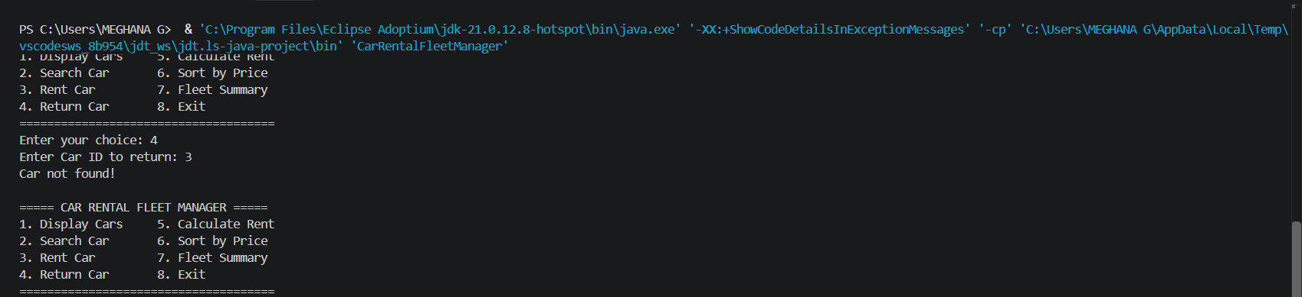

SLIDE 10: Sample Console Output (Additional)
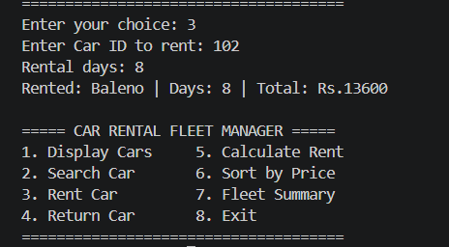

SLIDE 11: Worked Example & Logic Walkthrough
Scenario: Rent a Hyundai Creta
Car Selected
Creta — ID: 103 | Price: ₹2500/day
Rental Duration
3 days
Calculation Logic
Total Cost = Price per Day × Number of Days
Total Cost = 2500 × 3 = ₹7500
Modules Demonstrated
- Module 1: Arithmetic operators, variables
- Module 2: if-else conditions for availability check
- Module 3: Method parameters, return values
SLIDE 12: Conclusion & Future Work
Conclusion
The Car Rental Fleet Manager successfully demonstrates how fundamental programming concepts from Modules 1, 2, and 3 integrate into a practical, real-world application. Through this project, we've shown:
- Problem decomposition into manageable, reusable methods
- Effective use of data structures (arrays) for managing complex information
- Control flow logic (if-else, switch, loops) for decision-making and iteration
- Algorithm implementation (linear search, bubble sort) for data manipulation
- User input validation and error handling for robust applications
This project bridges the gap between theoretical programming concepts and practical problem-solving, equipping first-year CSE students with the foundational skills needed for advanced coursework in object-oriented programming, data structures, and software engineering.
Future Work & Advanced Extensions
The same project can evolve naturally into the next modules by strengthening structure, persistence, and scalability.
Module 4 Extensions:
- Implement Car and Customer as classes with encapsulation
- Use constructors and method overloading for flexible object creation
- Add exception handling for invalid inputs and edge cases
Module 5 Extensions:
- Persist fleet data to files using File I/O
- Parse CSV records for bulk car import/export
- Use StringBuilder for dynamic report generation
Module 6 Extensions:
- Replace arrays with Array List and HashMap for dynamic fleet management
- Implement Comparable interface for flexible sorting criteria
- Use Stream API for advanced filtering and aggregation
- Apply lambda expressions for custom search and sort operations
SLIDE 13: Thank You
Thank you for reviewing the Car Rental Fleet Manager project.
GitHub Repository: [Project Link]
"Programming is not about writing code—it's about solving problems systematically."

